Standard: Proper Standards-Compliant Color Contrast Use in Web Design

Tool: <http://wave.webaim.org/> . WAVE is a free community service empowered and administered by WebAIM. It is launched in 2001 and it is used to evaluate the accessibility of web pages and web content. It is Originally sponsored by Temple University Institute on Disabilities. There are extensions for evaluating dynamic, local, password-protected pages and site-wide WAVE tools in Firefox and Chrome to easily evaluate numerous pages.

Results:

Screenshot of the result of the Color Contrast Validator on <http://www.megaworldfoundation.com/>

Figure 1.0

For the <http://www.megaworldfoundation.com/> , There are 20 Contrast Errors and these errors are mostly found on the texts that are seen in the website. (See Figure 1.0)

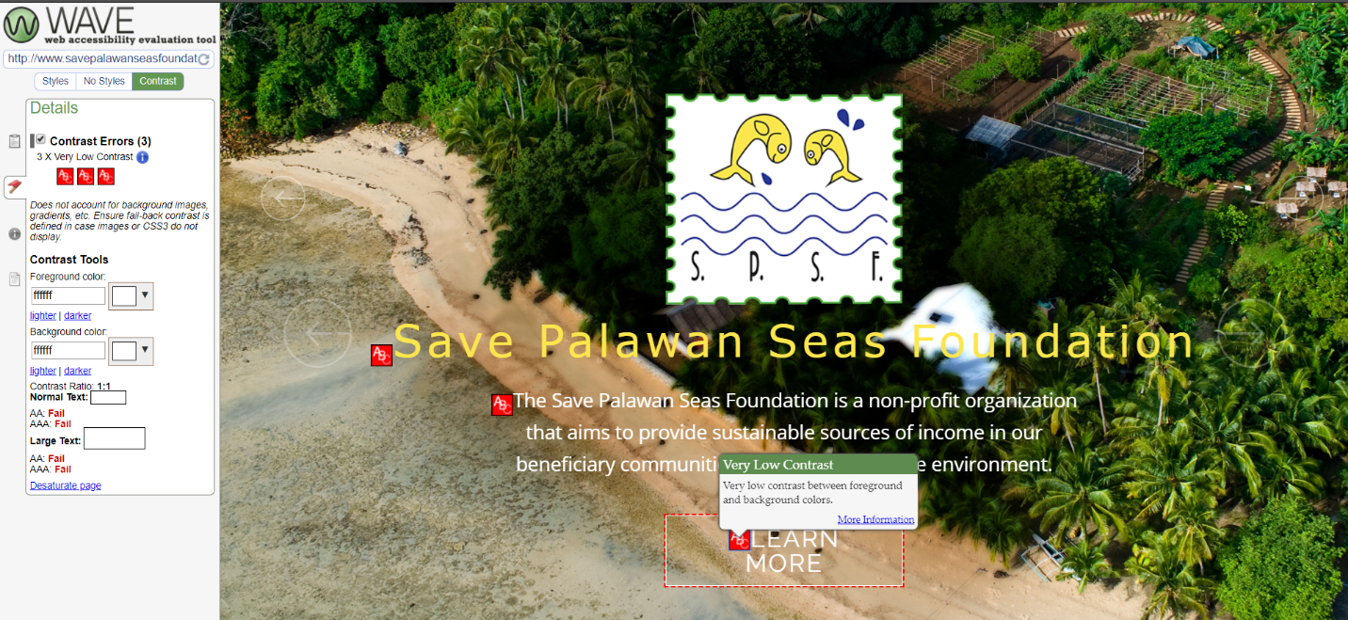

Screenshot of the result of the Color Contrast Validator on <http://www.savepalawanseasfoundation.org>

Figure 1.1

For the <http://www.savepalawanseasfoundation.org> , There are only 3 Contrast Errors and these errors are mostly found on the texts that are seen in the Homepage of the website. (See Figure 1.1)

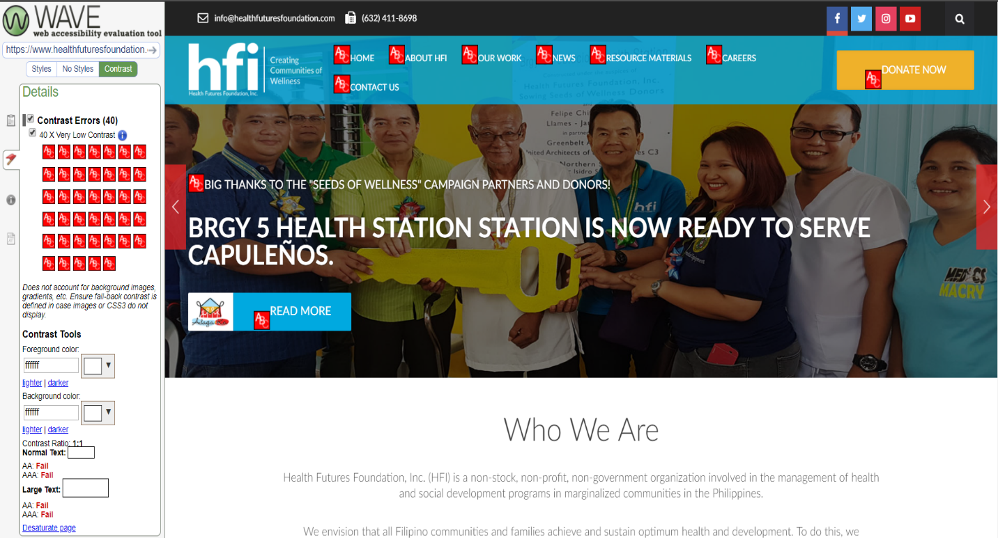

Screenshot of the result of the Color Contrast Validator on <https://www.healthfuturesfoundation.com/>

Figure 1.2

For the <https://www.healthfuturesfoundation.com/> There are 40 Contrast Errors and these errors are mostly found on all of the texts in the website. (See Figure 1.2)

Comparative Analysis: The design of each website impacts on how end users perceives them. From color to other more standards always create a first impression. Color contrast has a very big impact on the digital end users experience in many ways. Based on the results, all the websites that are tested encountered contrast errors. However, among the three websites , the <http://www.savepalawanseasfoundation.org> has the least number of Contrast Errors , it may passed on the Proper Standards-Compliant Color Contrast Use in Web Design. The <http://www.savepalawanseasfoundation.org> is having content that is readable, organized and understandable to those people who would visit the web page. The website that got a lot of contrast error is the <https://www.healthfuturesfoundation.com/> and it is 40 errors. However, the <http://www.megaworldfoundation.com/> got 20 contrast errors.

Standard: Website Optimization

Tool: <https://varvy.com/pagespeed/>

It is a tool that communicates on basic knowledge on the individual areas that is very important on website optimization. On each area of optimization there is an article that explains the aspect about it. The modern websites need to meet a lot of standard and requirements like how fast the website is loads and how optimized it is for search engines. This tool covers all areas and has so many features.

Results:

|  |  |  |  |
| --- | --- | --- | --- |
| Standard | <http://www.savepalawanseasfoundation.org/> | <https://www.healthfuturesfoundation.com/> | <http://www.megaworldfoundation.com> |
| Server | It has a Slow server response and its Compression enabled but the webpage has Browser caching issues. The Keep-alive is also enabled and has a Minimal redirects. |  | It has a Quick server response time. The Compression not enabled. I has Browser caching issues but the Keep-alive is enabled. It has Minimal redirects |
| Page | There are Bad requests found and HTML is not minimized. The Request size is fine and its Visible content is prioritized but there are render blocking CSS / JS found |  | There are Bad requests found and HTML is not minimized. The Request size is fine and its Visible content is prioritized but there are render blocking CSS / JS found |
| Resources | Images not optimized and Javascripts seem async. CSS is not minimized. There is No @import CSS and Javascript is not minified  There are 24 js files and 4 images and 6 css files. |  | Images not optimized and Javascripts seem async. CSS is not minimized. There is No @import CSS and Javascript is not minified  5 js files / 18 images / 5 css files |
| CSS Delivery | There is a 1 Render blocking CSS files  http://fonts.googleapis.com/css?family=Raleway:400,700    There are Less than 75k of CSS. And it is very Excellent But is has Too many external CSS files. There are Render blocking CSS files. There are 2 CSS files were called using @import.  There is No in element CSS found and CSS is not minimized. |  | There are 4 Render blocking CSS files  http://www.megaworldfoundation.com/Portals/_default/default.css  http://www.megaworldfoundation.com/Portals/0/Skins/Green_Megaworld_foundation/skin.css  http://www.megaworldfoundation.com/Portals/0/Skins/Green_Megaworld_foundation/css/menu.css  http://www.megaworldfoundation.com/desktopmodules/LiveContent/themes/default/default.css  There are Less than 75k of CSS. And it is very Excellent But is has Too many external CSS files. There are Render blocking CSS files. There are 1 CSS file were called using @import.  There is an In element CSS found and CSS not minimized. |
| CSS size | 5k |  | 58k |
| External | 4525 / Internal: 369 / In attribute: 0 |  | External: 55287 / Internal: 0 / In attribute: 2432 |
| JavaScript usage: | There are 0 Render blocking JS  No render blocking JS found. Excellent.  Over 300k of JavaScript  Three or more external JS files  No render blocking JS |  | There are 14 Render blocking JS  http://www.megaworldfoundation.com/WebResource.axd?d=jd0qHkiSth6ZUcrXe-C6YYClHO2H8TuF_DI9yZYRGxLgiEius2pBWXTMv0NStmL5bcJ-xuZuE07t0Tpu0&t=635654745757562500  http://www.megaworldfoundation.com/js/dnncore.js  http://www.megaworldfoundation.com/desktopmodules/LiveContent/js/swfobject.js  http://www.megaworldfoundation.com/desktopmodules/LiveContent/js/livecontent.js  http://www.megaworldfoundation.com/ScriptResource.axd?d=a0OMVC0Nr1NoR5yGBR8EBHlSNLpq7-pPbIirDW9zV33itGp_aolLycAkB5zyGaBFY6oeXRg4k3TmFWMmtMdR7qHHngq-oDCQxMAq4tNM-_6cEYmKfX0X29B0ooRcc1MLwe_7zvGDLh0O2t0kLi8IWTQiuj41&t=ffffffff9d263a38  http://www.megaworldfoundation.com/ScriptResource.axd?d=XOX7canWB49zDE1gl6pjV6HgnFwApOs_ALDkIsR1698tLqrc63_6ydJLzD9uRTMNl7L7bKoRNn0LUrgZQ2ugjenv8oAOykZtJUbKFBvOSAVMs6Z02OpX6CaEVYg1AbBKOvJ51lakebtvPp6kYuUoY_IC6idbhDjxtaK2hA2&t=ffffffff9d263a38  http://www.megaworldfoundation.com/js/dnn.js  http://www.megaworldfoundation.com/js/dnn.xml.js  http://www.megaworldfoundation.com/js/dnn.xml.jsparser.js http://www.megaworldfoundation.com/js/dnn.xmlhttp.js  http://www.megaworldfoundation.com/js/dnn.xmlhttp.jsxmlhttprequest.js http://www.megaworldfoundation.com/js/dnn.dom.positioning.js  http://www.megaworldfoundation.com/js/dnn.controls.js  http://www.megaworldfoundation.com/js/dnn.controls.dnnmenu.js |
| Total JavaScript size | 323 k |  | 99k |
| External | 320430 |  | 95950 |
| Internal | 2749 |  | 2764 |
| Image Optimization | There is an image performance issues found  masthead2.jpg | Not Optimized | Could save 150.4KiB if optimized (17%) |  | There are image performance issues found on 17 images. These images are not optimized. |
| Browser Caching | The Browser caching not enabled for all resources. It is Not enabled for this domain. It is Not enabled for third party resources |  | The Browser caching not enabled for all resources. It is Not enabled for this domain. It is Enabled for third party resources |
| Keep Alive | Keep Alive enabled for all requests. Enabled for local resources.Enabled for third party resources  Local resources:  Resources served from origin domain have keep-alive enabled.  Third party resources:  No third party keep-alive issues found. |  | Keep Alive enabled for all requests. Enabled for local resources. Enabled for third party resources  Local resources:  Resources served from origin domain have keep-alive enabled.  Third party resources:  No third party keep-alive issues found. |
| Enable Compression | Compression is enabled for all resources. Enabled for local resources. Enabled for third party resources  This domain:  No compression errors found for resources served from origin domain.  Third party domains:  No third party compression errors. |  | Compression not enabled for all resources. Not enabled for local resources. Enabled for third party resources  This domain:  http://www.megaworldfoundation.com/desktopmodules/LiveContent/js/livecontent.js  http://www.megaworldfoundation.com/Portals/_default/default.css  http://www.megaworldfoundation.com/ism/js/ism-2.2.min.js  http://www.megaworldfoundation.com/js/dnn.controls.dnnmenu.js  http://www.megaworldfoundation.com/WebResource.axd?d=jd0qHkiSth6ZUcrXe-C6YYClHO2H8TuF_DI9yZYRGxLgiEius2pBWXTMv0NStmL5bcJ-xuZuE07t0Tpu0&t=635654745757562500  http://www.megaworldfoundation.com/js/dnn.js  http://www.megaworldfoundation.com/ism/css/my-slider.css  http://www.megaworldfoundation.com/js/dnncore.js  http://www.megaworldfoundation.com/Portals/0/Skins/Green_Megaworld_foundation/skin.css  http://www.megaworldfoundation.com/js/dnn.controls.js  http://www.megaworldfoundation.com/desktopmodules/LiveContent/js/swfobject.js  http://www.megaworldfoundation.com/js/dnn.dom.positioning.js  http://www.megaworldfoundation.com/js/dnn.xmlhttp.js  http://www.megaworldfoundation.com/js/dnn.xml.js  http://www.megaworldfoundation.com/js/dnn.xml.jsparser.js  http://www.megaworldfoundation.com/desktopmodules/LiveContent/themes/default/default.css  http://www.megaworldfoundation.com/Portals/0/Skins/Green_Megaworld_foundation/css/menu.css  http://www.megaworldfoundation.com/js/dnn.xmlhttp.jsxmlhttprequest.js  Third party domains:  No third-party compression errors.  If these resources were compressed it would save 170KiB (a 70% reduction). |
| Server response Time | Server responded in 0.41 seconds.  Slow server response  Google recommends a server response time of less than 200 milliseconds. |  | Server responded in less than 200 milliseconds  Quick server response time  Google recommends a server response time of less than 200 milliseconds. |